14. Create a HTML web page, change the position of the element absolute to get two elements over each other using absolute positioning with a CSS file.
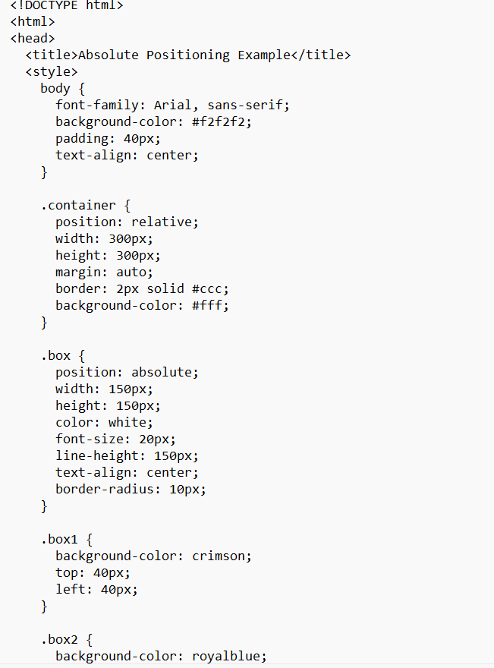 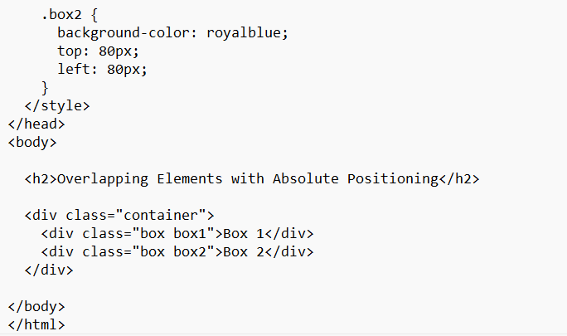output
